FLR Large reef associated gropers (baldchin groper and western blue groper in FDO), break sea cod (in FDO), dory, giant boarfish, boarfish, blue devil eastern (western blue devil), green moray, hapuku, harlequin,

**John Dory** Zeus faber

Stomach content analysis of *Z. faber* indicated that the most important prey group was Pisces (97.34 IRI%), followed by Crustacea (0.55 IRI%) (Table 3a). Identified fish included Mullus barbatus (0.08 IRI %), Cepola rubescens (0.05 IRI%), Engraulis encrasicolus (1.82 IRI%) and Sardina pilchardus (0.10 IRI%). Results of the Index of Relative Importance (IRI%) showed that Pisces were the most important prey group in the diet of *Z. faber* while the Crustacea were in second place. Silva (1992) studied the diet of *Z. faber* at Portuguese coasts and found them to be highly ichtyophagous (Velasco and Olaso, 1998). Among the identified Pisces, Sardina pilchardus and Cepola rubescens were also reported by Velasco and Olaso (1998) in the Cantabrian Sea from stomach contents of *Z. faber*. However, Stergiou and Fourtouni (1991) indicated that, in addition to Pisces and Crustacea, the diet of *Z. faber* contained cephalopods and other mollusks in the Euboikos and Pagassitikos gulfs, Greece.

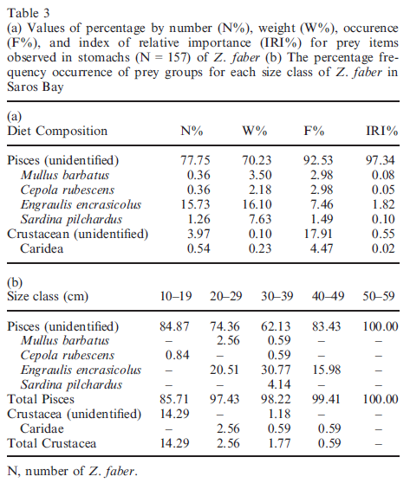

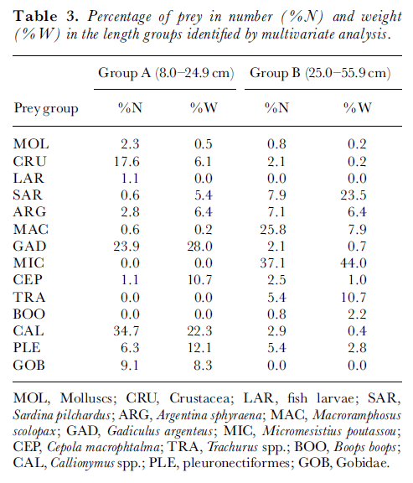

*Callionymus* spp. (dragonets) and *Gadiculus argenteus* (silvery pout) represented about 50% of group A prey, both in numbers and in weight. On a numbers basis, Crustacea, Gobiidae and pleuronectiforms were also important food items. However, Crustacea were relatively less important when weight was considered and *Cepola macrophthalma* (redband fish) increased in importance despite being represented by only two individuals. For group B, *Micromesistius poutassou* (blue whiting) and *Macroramphosus scolopax* (snipefish) were the most important prey in numbers basis (37.1 and 25.8% respectively). In terms of weight, snipefish was replaced by *Sardina pilchardus* (sardine). *Trachurus* spp. (horse mackerel and

Jack mackerel) and *Argentina sphyraena* (argentine) were also of moderate importance for this length group. The results of this study indicate that, at around a length of 25 cm, John Dory undergoes a major dietary change. It gradually moves from a diet characterized by small fish species such as dragonets, silvery pout, Gobiidae and crustaceans (mainly Pandalidae), to a diet dominated by larger ¢sh species such as blue whiting and sardine. Snipefish, although a relatively small fish, is also numerically an important prey for larger John Dory. This is probably more due to the great abundance of this species in the Portuguese waters than the re£ection of a true food preference. Stergiou & Fourtouni (1991) studied the food habits and ontogenetic diet shifts of John Dory in the eastern Mediterranean. Based on a similar range of fish lengths, they identified a single dietary shift around 14 cm total length. This corresponds to the transition from a diet dominated by mysids, Callionymus maculatus Ra¢nesque and Deltentosteus quadrimaculatus Valenciennes to a diet dominated by C. macrophthalma, Spicara £exuosa Ra¢nesque and Serranus hepatus. The smaller length group was also divided into a zooplanktophagous stage (5.1^8.0 cm fish) and a transitional stage to piscivory (8.1^14.0 cm ¢sh). In a sample of nine individuals in the length range 2.7-11.7 cm from the west coast of Scotland, Gibson & Ezzi (1987) also found that mysids and small benthic fish were the main prey of John Dory. The feeding spectra of John Dory with lengths of less than 14 cm in the eastern Mediterranean (Stergiou & Fourtouni, 1991) closely resembles that of individuals of up to 25 cm analysed in this study, i.e. main prey species correspond to small benthic ¢sh and crustacea. The same genera and species are even observed in the two areas. On the other hand, the species composition of the diet of larger fish differs considerably in the two areas. In the eastern Mediterranean John Dory changes to a diet characterized by larger demersal fish and C. macrophthalma is largely dominant, whereas in Portuguese waters John Dory feeds mainly upon larger pelagic ¢sh and blue whiting is dominant.

References:

Silva, A., 1999: Feeding habits of John Dory, Zeus faber off the Portuguese continental coast. J. Mar. Biol. Assoc. U.K. 79, 333–340.

Velasco, F.; Olaso, I., 1998: John Dory Zeus faber (Linnaeus, 1758) feeding off Galicia and in the Cantabrian Sea: dietary shifts with size. Bol. Inst. Esp. Oceanogr. 14, 69–79.

A. Ismen, M. Arslan, C. C. Yigin and N. A. Bozbay 2013. Age, growth, reproduction and feeding of John Dory, Zeus faber (Pisces: Zeidae), in the Saros Bay (North Aegean Sea) J. Appl. Ichthyol. 29 (2013), 125–131

Stergiou, K.I. & Fourtouni, H., 1991., Food habits, ontogenetic diet shift and selectivity in Zeus faber Linnaeus, 1758. Journal of Fish Biology, 39, 589-603.

**boarfish**

giant boarfish Paristiopterus labiosus occurs from northern NSW to southern Tasmania and south WA (<http://australianmuseum.net.au/Giant-Boarfish-Paristiopterus-labiosus>). mostly lives in deep water down to 200 m. Sometimes it is observed in shallower water swimming over sandy or muddy bottoms no info

longsnout boarfish Pentaceropsis recurvirostris occurs from Sydney to Rottnest Is occurs in very shallow rocky reefs down to depths of around 260 m. no info

blackspot boarfish Zanclistius elevatus occurs from southern Qld to southern WA and Tasmania The species is most often taken at depths of just less than 100 m, but it has been recorded to 540 m no info

Parazanclistius hutchinsi no info

<http://www.dpi.nsw.gov.au/__data/assets/pdf_file/0005/375863/Boarfish.pdf>

Deepbody boarfish Antigonia capros occurs in tropics WA Feed on small mollusks and crustaceans (http://www.fishbase.org/summary/3258)

**The Western Blue Devil** (*Paraplesiops meleagris*) found in South Australia, Victoria (to Wilsons Promontory), and WA (to Houtman Abrolhos) between 5 m and 45 m deep. They eat other bony fish and benthic crustaceans (e.g. crabs), and are described as ‘generalist carnivores’.

**Green moray** Gymnothorax prasinus Green Morays can be found in shallow rocky reefs, weed-covered reefs, in estuaries and in deeper offshore waters. All morays are carnivorous

<http://australianmuseum.net.au/Green-Moray-Gymnothorax-prasinus/>

**Hapuku** *Polyprion oxygeneios* Inhabits deep offshore waters to approximately 200 fathoms in southern NSW, Victoria, Tasmania, South Australia and southern Western Australia from 20 but in Australia: 200-500 m (<http://www.dpi.nsw.gov.au/__data/assets/pdf_file/0010/375904/Hapuku.pdf>)

Corey B. Wakefield, Stephen J. Newman and Brett W. Molony 2010 Age-based demography and reproduction of hapuku, Polyprion oxygeneios, from the south coast of Western Australia: implications for management. ICES Journal of Marine Science

Adults occur generally over rough ground from the central shelf (about 100 m) to the shelf edge and down to the upper slope. Juveniles are found in surface waters, perhaps school in association with drifting weed. Feed on barracouta and pilchards, in addition to various bottom-dwelling fish. (<http://fishbase.sinica.edu.tw/Summary/SpeciesSummary.php?id=350>)

Generally, Hapuku feed on a variety of fish (including both pelagic and bottom species), and benthic invertebrates. In New Zealand, Hapuku are reported to feed on Red Cod *Pseudophycis bachus*, Blue Cod *Parapercis colias*, Jackass Morwong *Nemadactylus macropterus*, Hoki *Macruronus novaezelandiae*, and calamari (New Zealand Ministry of Fisheries, 2004f). A study in Chile showed that Hapuku feed on bony fishes (such as pilchards, grenadiers, slimeheads, saury, sea basses, damselfishes, barracouta, redbait, morid cods, morwongs, horse mackerel and conger eels), lobsters and stomatopods (Rojas et al., 1985, cited in Froese and Pauly, 2008).

**Harlequin** *Othos dentex* Feeds on various small fish

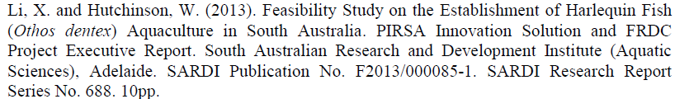

<http://fishbase.sinica.edu.tw/Summary/SpeciesSummary.php?id=14355>

John Dory 10-19 cm **1-2**

|  |  |
| --- | --- |
| **prey item** | **probability of consuming** |
| FMA | 0.1 |
| SAR | 0.3 |
| FSR | 0.1 |
| FDT | 0.1 |
| FMA | 0.1 |
| FDC | 0.1 |
| BG | 0.2 |
| MAZ | 0.2 |
| LOJ | 0.2 |
| LOB | 0.2 |
| PRW | 0.2 |

John Dory 20-29 cm **3-4**

|  |  |
| --- | --- |
| **prey item** | **probability of consuming** |
| FMA | 0.1 |
| SAR | 0.3 |
| FSR | 0.1 |
| FDT | 0.1 |
| FMA | 0.1 |
| FDC | 0.1 |
| BG | 0.1 |
| MAZ | 0.1 |
| LOJ | 0.1 |
| LOB | 0.1 |
| PRW | 0.1 |

John Dory 30-39 cm **5-6**

|  |  |
| --- | --- |
| **prey item** | **probability of consuming** |
| FMA | 0.2 |
| SAR | 0.2 |
| FSR | 0.2 |
| FDT | 0.2 |
| FMA | 0.2 |
| FDC | 0.2 |
| BG | 0.05 |
| MAZ | 0.05 |
| LOJ | 0.05 |
| LOB | 0.05 |
| PRW | 0.05 |

John Dory 40-49 cm **7-8**

|  |  |
| --- | --- |
| **prey item** | **probability of consuming** |
| FMA | 0.2 |
| SAR | 0.15 |
| FSR | 0.2 |
| FDT | 0.2 |
| FMA | 0.2 |
| FDC | 0.2 |
| BG | 0.02 |
| MAZ | 0.02 |
| LOJ | 0.02 |
| LOB | 0.02 |
| PRW | 0.02 |

John Dory 50-59 cm **9-10**

|  |  |
| --- | --- |
| **prey item** | **probability of consuming** |
| FMA | 0.2 |
| SAR | 0.05 |
| FSR | 0.2 |
| FDT | 0.2 |
| FMA | 0.2 |
| FDC | 0.2 |

Others from this group

Fish and benthic crustaceans